TITLE OF PAPERS IN ENGLISH

Pero Perović¹, Marko Marković²
¹ University of Banja Luka, Faculty of Natural Sciences, Mladena Stojanovića 2,
Banja Luka, Republic of Srpska, e-mail: peroperovic@blic.net
² University of East Sarajevo, Faculty of Technology, Karakaj bb,
Zvornik, Republic of Srpska, e-mail: markomarkovic@gmail.com

Abstract:...............................................................................................................
............................................................................................................................................
Keywords:..............................................................................................................
...........................................................................................................................................

- INTRODUCTION

The Academy of Science and Arts of the Republic of Srpska publishes the reviewed papers in the Journal Contemporary Materials.
The following categorized papers will be published in the journal:
- original scientific papers,
- brief scientific papers,
- reviews,
- professional papers,
- information supplement (editorial, comment),
- overview,
- book review.
The maximum size of the papers published is 16 pages. A paper, besides the text, includes figures, photographs and tables.
The journal will be written in English. Author(s) of the papers will be responsible for the contents, authenticity and originality of papers, as well as for any other consequences that may arise from their publishing.

2. TEXT

Papers should be written in Word (font Times New Roman), А4 format, margins 2 cm.
Title of the paper in Serbian and English language should be written in capital letters, with central alignment, font size 14 pt, two line spacing from the upper margin (line spacing is 11 pt).
Names of the authors (initial letter of the first name, full last name) are written at one line spacing after the title, while the full name of the institution in which their work is written below, in central alignment, font size 12 pt.
The abstract and key words should be written two lines below the name of the institution, font size 10pt, alignment: justify. Indentation is 2 cm from both sides. Words summary and abstract are written in bold letters.
The text of the scientific paper should be written with line spacing 1, font size 11. Indentation of the first line of paragraph is 1 cm.

2.1. Sub-titles

Sub-titles are written in capital letters, separated by two lines from the previous text, and one line from the text that follows, font size 11 pt, first line indentation 1 cm.
Sub-titles of lower rank are written in regular font, font size 11 pt, one line separated from both the previous and the following text, first line indentation 1 cm.

3. ILLUSTRATIONS

Illustrations (tables, figures, diagrams) should be marked. Legends, i.e. explanations that follow the illustrations should be numbered whereby the number of the figure, i.e. of the table indicates the corresponding reference in the text. With figures, legend should be written below and with tables legend should be written above the text (font size 10 pt, italic). With figures, legend is aligned centrally (single spacing above, two below). With tables, right alignment (aligned with the edge of the table, double spacing above). All illustrations must be black and white and of appropriate quality. If possible, equations should be written in one column, if not, in two. Numeration of formulas (in brackets) should be written along right margin.

Example of writing formulas:
$G_{n_{l};m_{l}}=\frac{iℏ}{2πX}\frac{D_{n_{l};m_{l}}}{D}$, (7)

Example of insertion of figures:
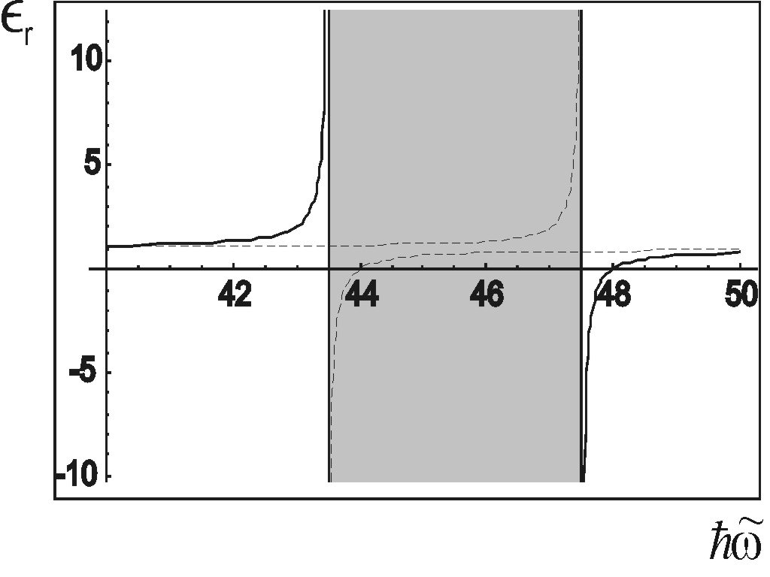
Figure 1. Dependence of dielectric permittivity on energy (frequency) of external field for bulk structures.

Table 1. ...................................

4. REFERENCES

References at the end of the text should be written in square brackets according to the order of quoting.
Papers published in journals are stated in the following manner:
[1] Author(s), title of the paper, name of journal, volume, number (year of edition) page x–y.
E.g. [1] M. A. Montealegre, et al., Surface treatments by laser technology, Contemporary Materials, Vol. I−1 (2010) 19−30.
Papers published in conference proceedings:
[2] Author(s), title of the paper, name of conference proceedings, place of publishing, year, page x–y. If the reference (literature quote) is not in English, in the end of reference quote, the language in which it is written should be mentioned in brackets.
E.g. [2] G. Keković, D. Raković, D. Davidović, Non-Linear Excitations of Quasi-Dimensional Structures of Polymer Transitions, Conference Proceedings „Contemporary Materials“ Banja Luka 2008, 71−81.
[3] V. Veselinović, N. Gajić, N. Trtić, R. Arbutina, Đ. Mirjanić, Komparativna analiza materijala za izradu nadogradnji kod endodontski lijepenih zuba – biomimetski aspekti, Zbornik radova “Savremeni materijali”, Banja Luka 2014, 277‒303 [In Serbian].
Books are stated in the following manner:
[3] Author(s), title of the book, publisher, place of publishing, page x–y.
E.g. [3] M. Kojić, General Concept of Implicit Integration of Constitutive Relations for Inelastic Material Deformation, The Centre for Scientific Research of SANU, Kragujevac 1993, 81−87.
[4] Quotes of internet pages should be avoided. If necessary, they should comprise the names of authors, if any, title, internet page and date of access.
E.g. [4] M. Braungart, W. McDonough, and A. Bollinger, Cradle-to-cradle design: creating healthy emissions e a strategy for eco-effective product and system design, 2007. Available: http://www.ima.kth.se/utb/MJ1501/2010/Cradle1.pdf. [Accessed: 4 April-2015].



НАЗИВ РАДА

Сажетак:................................................................................................................
...........................................................................................................................................
Кључне ријечи:....................................................................................................
............................................................................................................................................



